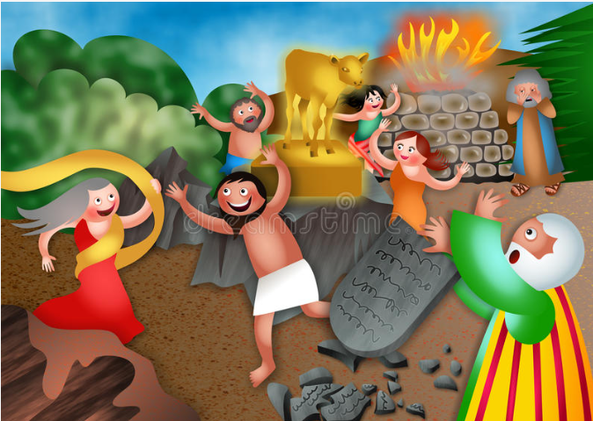
Father forgive us, we have strayed.

Days of Awe
Sept 25-Oct 5
Rosh Hashana – Yom Kippur
Celebration of Creation & Remembrance of God’s forgiveness
A season of spiritual cleansing
a Sweet Aroma
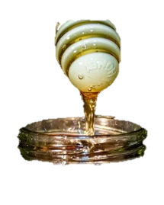
to the Lord
A Christian Devotional Guide for the
DAYS of AWE, celebrated on the Jewish calendar.

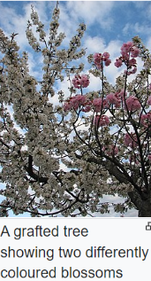
Sunday, Sept. 25 We are Grafted In Suggested Reading Romans 11
As Christians we have been grafted into the family of God. Originally God’s covenant with man was through the Jews. It is by His grace and the sacrificial blood of the lamb on the altars of our hearts that Christians may also know and experience the fullness of life God offers.
Just as the Jews experienced and remember the Passover Lamb by placing the blood on their doorposts that had the angel of death Passover their household, the blood of Jesus Christ placed on our hearts frees us from the grip of the angel of death and releases us into the abundance of eternal life on earth and in days to come in heaven.
Though the Hebrew calendar traditions are not inherently grafted into the Christian calendar, it is fitting to reflect upon what God set in motion through these roots. It is also fitting to cleanse our hearts before the Lord and prepare to enter into His presence as did the High Priest in the Holy of Holies after a week of preparation soul searching self examination and seeking reconciliation and a day of prayer and fasting. Christ calls all to the royal priesthood and encourages us to enter into His presence.
Rosh Hashana which includes the the Feast of the Trumpets starts at sunset today. It is a celebration of the creation, shofars are blown, apples dipped in honey and other sweet foods, challah - a braided bread, and new fruits are served in celebration of new beginning and in remembrance of God’s creation. It ushers in a week of reconciliations, repentance, and restoring relationships that ends with Yom Kippur, a day prayer and fasting with deep introspective repentance and high holiness to enter into God’s Holy Presence and to have your name written in the book of life. It is season of remembrance of Bible stories about forgiveness. It recalls God’s great act of forgiveness when the people had built the golden calf while Moses had gone to Mt. Sinai and brought them the Ten Commandments. Learn more about Rosh Hashanah at Chabad.org
This devotional series will give you background on the Jewish traditions, share some testimonies and reflections on forgiveness and be a guide to exercises in repentance, deliverance and cleansing.
PRAYER: Father, as we enter into this season in harmony with the Jewish heritage we’ve been graciously grafted into, may it be a sweet aroma to bring us closer to you, Lord. As hearts are cleansed, through repentance and reconciliations, move through us, birth the seeds of revival we know our state and nation desperately need.
Monday, Sept. 26 Celebration of Creation Suggested reading/viewing
Genesis 1-2 click for a 3 min. video

Today pause and reflect upon the wonders of creation that our Great God Almighty spoke into being. Consider the beauties, uniqueness, awesome expanses – from all the galaxies and to the inner mysteries of cell structure, antibodies to ward of disease and all the delicate balances and interactions of the nitrogen, water, photosynthesis, soil composting cycles… that God created to sustain your life. He is an awesome God, forever worthy of our praises.
God did not want man to be a robot, but to freely choose to bring Him worship. The Jewish temple in the wilderness was a place for 24/7 prayers and praise. They paid to have a choir and instruments, some professional musicians, though most filled in as best they could.

For the past few years, nationwide prayer endeavors have surfaced. These may be a few lesser known ones, but worthy of your awareness, God loves our prayers. David’s Tent and Tent America.Awaken the Dawn have had 24/7 ongoing worship on the Capitol DC Mall with spokes into each state. Ten Days of Prayer, sets aside ten days fall and spring to seek Him and worship in communities. World for Jesus and periodically has a Gathering of the Eagles before covid in person an since it has been a week of nightly intercession – happening this week. An important one in this season. It is led by a Messianic Jew. All of these groups are multi-denominational accentuating prayer & praise. Prayer is vital to the Lord. He wants to hear from us. Encourage prayer cell formations in your community.

Father, it is our delight to bring remember your wonderous deeds and bring you praise. Your creation is perfect and glorious in so many ways. May we pause more often to appreciate it’s wonders. We lift to you a new song of praise, pray a psalm of praise along with King David who wrote Psalm 100 and Psalm 150. Great is your name, and greatly to be praised. Let all that has breath – praise Your Holy name.
Tuesday, Sept. 27 Sin needs Forgiveness Suggested reading /viewing Genesis 3
As Adam & Eve disobeyed God and ushered in a pandora’s box of sin, we too, have chosen to go our own way and not always followed God. The root of sin is the middle letter “I.” I want it my way and I’ll do whatever it takes – lie, steal, cheat, murder… I, I, I. Thank God, He provided us with a sacrificial lamb’s blood on the altars of our hearts that we may know God’s forgiveness and have our names placed in the Lamb’s Book of Life.
I
Most Jews are still waiting for their Messiah and don’t realize Jesus is the one they are waiting for. For them this upcoming week of introspection and repentance is vital in order that they may have their name written for the coming year in the Book of Life, this happens on Yom Kippur at the end of the Days of Awe.
Paul walked in heaven unsure if he was in flesh or in the spirit before he wrote the book of Revelation. Nita Johnson, the prophetic leader of World for Jesus, describes these experiences, too, click here. More prayer is needed she says. Consider joining the intercession at WFJ at 7:30pm at 717-908-1834 Access code 182152# Tuesday-Friday of this week.
Father, thank you for the blood of Jesus on our hearts. In Hebrews we see that this is your plan, that for once and for all time, Jesus paid the price for us to be set free and walk in fellowship with you. We thank you that you are our Abba, our dear dearest Daddy. Prepare us this week to reflect upon our sinful tendencies and make efforts to cleanse and mend our ways to more readily reflect your ways in our lives. Bless our friends and family and heal broken relationships.

Wednesday, Sept. 28 Cleansing our Hearts Suggested readings below

In this week, Jewish are encouraged to seek out those they have ruffled and to seek reconciliation and forgiveness. The Bible tells Christians to do this before they have Communion. This has not been emphasized very often, and our lists today may be long as a result, but make the list and do what you can to follow through – meet, write, call…and seek the Lord to bring cleansing to your heart

1. Esau forgave Jacob for stealing his birthright in Genesis 33 it was equivalent to a lot of fame and fortune in today’s world. Reflect on how you may seek to take the limelight or keep others from their well-deserved credit, income and opportunity to grow in their endeavors.

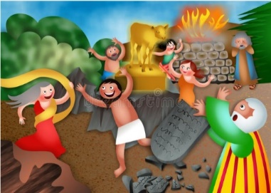
2. Joseph’s brothers attempt to murder him and sell him into slavery. Years later the brothers are at his mercy. Genesis 30-50 Joseph forgives them and shows kindness and love to them. Reflect on ways you have or could return good for evil and how it serves God’s justice.

3. Time and time again in the wilderness journey (Exodus) the people of Israel disobey and complain God forgives them. Reflect on how complaining affects you. Do you forgive or let it broil you?

Father, we thank you for your great example of offering us forgiveness. Guide us this week as we seek to cleanse our hearts. Help us point limelight to others, avoid setting traps to harm to others, and turn our complaints into an opportunity to forgive. Grow us in humility, reverence and obedience and appreciation of joys in the life that surrounds us.
Thursday, Sept. 29 Set FREE Suggested Reading – Matthew 8
The story of Jesus setting free the insane, wild man by casting out demons into a herd of pigs that restored his right mind is vitally needed today. Jesus sent the disciples to set other captives free. There are many Vermonters in need of this kind of help. The same repentance and forgiveness guides we use can be helpful in setting others free, too. The outline below is for personal reflection only, but others can use the same outline. It has long been used by someone with a deliverance ministry to prepare the heart to be set free. No one, but God need see the responses. Burning them to ashes once you pray and release them to the Lord is recommend. Use your list to guide prayers in a confession like environment. For Jews this happens once a year on Yon Kippur(Oct.5), for Catholics it happens as needed with the priest at confessions, and Protestants come as needed before Christ perhaps with a pastor, counselor, or friend - ideally before communion (I Cor.11:27-31)

The heart of The Days of Awe revolves around confession and forgiveness to realign hearts with God. This devotional seeks this as well.

UNFORGIVENESS: List all people from childhood to the present whom you now have or have ever had any unforgiveness or resentment towards (dead or alive).

OCCULT: List all dealings you have had with the occult (example: Ouija, séance, horoscope, new age, superstition, witchcraft, oaths, santeria, palm reader, roots, etc.)

SEXUAL SIN: List all people you have been sexually involved with outside of marriage (example: rape, molestation, incest, homosexual/lesbianism, bestiality, even your spouse if you came together sexually prior to marriage.

SOUL TIES: List all people (dead or alive) that have had an ungodly control over you. Also your mother, father, step parents, spouse(s), grandparents, boss, spirit guides, abortions, hypnotist, ex-spouse(s), brothers/sisters (step or half), children (step, adopted, foster), etc., also include names from #3 above, sexual partners.

Father, like the wild man, all of us have allowed ungodly influences to penetrate us. Help us use your godly armor (Ephesians 5) to protect our minds, our heart, our loins, our feet, and shield us with faith and a skilled sword. Guide our remembrances and lead us in restoration.
Friday, Sept. 30 Showing Mercy & Justice Suggested readings/video below.

Sin has abounded throughout history and there are profound examples in both the Old and New Testament. God has repeatedly responded with kindness and forgiveness when asked. Jesus brought this message to people where ever He went. To see Jesus’s response to people he helped click here and read the stories below.

The story of the Woman Caught in Adultery is found in John 8:1-11. By law in their time this woman should have died, but Jesus begins writing on the ground. It moves all of her accusers to leave. Jesus simply tells her, “Neither do I condemn you, go and sin no more.”

The Parable of the Prodigal Son is found in Luke 15:11-32. The prodigal son inherits his father’s wealth and wastes it on “wild living.” At rock bottom he returns to his father and begs his forgiveness. The father gives him a great homecoming party. What a loving fatherly response.

Apostle Paul conversion to Christianity and forgiveness story is found in Acts 8 and 9. After hating Christians and persecuting and killing them, Paul had an encounter with Jesus on the road to Damascus and it changed his life! God gave him a 180 degree turnaround and set him on a road to bring others to serve him.

Today there are other champion racehorses that have been on the wrong track and God resets their course. They sometimes make effective leaders to show others His way.

Seeking avenues to show God’s justice is a vital piece of the Days of Awe, too. What ways can you use the gifts God has given you to help others be set free, better understand God’s ways, and encourage those who have wandered astray?

Father, help us to truly reflect on ways we can show mercy and your kind of justice to people in our community. Help us be the arms and feet of your love in our communities. Engage us as your light not only in our fellowship, but in our town where others need help seeing and understanding benefits of your ways.

Saturday, Oct. 1, How to forgive and let go of your past Joyce Meyers

Yes, God forgives, now how about forgiving yourself “Then neither do I condemn you,” Jesus declared. “Now go and sin no more.” -John 8:10-11 Don’t condemn yourself for things Jesus has set you free from. You may have previously done some dumb, stupid, harmful things, but that was in the past. Don’t keep beating yourself up for it. Jesus doesn’t. He set you free with forgiveness. Now walk in a newness of life. There may still be lingering consequences that need to be paid, but set your heart to walk in freedom.

See I am doing a new thing! Now it springs up; do you not perceive it? I am making a way in the wilderness and streams in the wasteland. -Isaiah 43:19
God is focused on the new things He is doing in your life! Turn your eyes to see it.

God saved you by his grace when you believed. And you can’t take credit for this; it is a gift from God. Salvation is not a reward for the good things we have done, so none of us can boast about it. For we are God’s masterpiece. He has created us anew in Christ Jesus, so we can do the good things he planned for us long ago. -Ephesians 2:8-10
It’s not about what you’ve done in your past–God has a future of good planned for you from long ago. Seek His guidance and walk into it.
This is a continuation of Thursday’s list of private heart introspection to seek the Lord for forgiveness and new freedoms to walk in.
COVENANT, VOWS: List all broken covenants and vows of the past. (marriages, church membership, etc.) More on the weekend.
PRIDE: List everything you are prideful of: (example: do you feel you have a better marriage than others, a better ministry, a better profession, know more Bible than others).

IDOLATRY: List all areas of idolatry. What stands between you and God? (Example: spouse, home, job/position, money, children, etc.)

UNCONFESSED SIN: List any unconfessed sin (example: you may have been born again ten years ago, but today you told a lie gossiped, or cheated someone). Any unconfessed sin will hinder your deliverance.

Father, we can’t be set free and return to hold on to our guilt. Thank you for giving us hope for new life, new freedoms, and walking with you as our guide. You are so good to us. Lead us into endeavors to share this hope with others in need. Thank you, oh God Most High & Holy for allowing us to be your children, with you as our dear Father.

Sunday, Oct. 2 How About Forgiving Others? Suggested videos & verses below

He brutally murdered my son, but I sought out his murderer to see if forgiveness could make a difference. It did.

Holocaust survivor’s forgiveness story. The Nazi’s killed my entire family, I alone have lived to a ripe age. Her grandparents were Nazi’s.

“But I say to you who hear, Love your enemies, do good to those who hate you, bless those who curse you, pray for those who abuse you.” -Luke 6:27
Jesus challenges us to not only forgive, but to love and pray and do good to those who have caused us harm. This is supernatural forgiveness that is only empowered by God.
Christ’s forgiveness for us compels our forgiveness of others in our life. Forgiveness doesn’t mean there are no consequences or boundaries, an abusive relationship on any level should not be tolerated. But rather true forgiveness is the release of justice into God’s faithful and loving arms.

Then Peter came to Jesus and asked, “Lord, how many times shall I forgive my brother or sister who sins against me? Up to seven times?” Jesus answered, “I tell you, not seven times, but seventy-seven times. -Matthew 18:21-22 The power of forgiveness is found in its abundance. God has abundantly forgiven me, I must also forgive abundantly.
A missionary kidnapped by guerilla terrorists in the jungles of S. America and held hostage in a Marxist indoctrination center, not only shared Christ’s love with his captors, but years later after being released he met up with the some of the same folks with warring parties accidentally coming together as new Christian believers. First, they lay down their weapons in the presence of their enemies. Then they considered well the opportunity to feast together before they negotiated peace accords that freed the jungle farmers from their ravaging raids. For more read Rescue the Captors, Russ Stendal
Father, we are forever indebted to you for the death Jesus suffered in order to allow us entrance into your holiest presence. Thank you for Christ’s sacrifice once for all of mankind willing to ask Him for forgiveness. We are so undeserving of His generosity. Let us walk in His example extending forgiveness to others and growing in love with you and our family.

Monday - Oct. 3 Kindness & Compassion suggested video and verses below Writing in the sand and stone told with pictures
Be kind and compassionate to one another, forgiving each other, just as in Christ God forgave you. -Ephesians 4:32 Kindness and compassion are how we see the person we need to forgive through God’s eyes. When we see them and ourselves through God’s eyes we know any good we do is through God working in us, not by any righteousness of our own.
Consider how do you interact with others on the job, at home, in the neighborhood, at church. It is appropriate to set boundaries, however examine the foundations for the boundaries and know when to be flexible. Does kindness and compassion remain in the foreground?
Do you keep others out because they aren’t intellectually stimulating? Do you view some as scum bags, not worthy of your time? Do you scramble to self-promote your ambitions? How transparent are you willing to be with your reasons? Are you approachable? Are there some who are less human in your world view?
Make my joy complete by being of the same mind, maintaining the same love, united in spirit, intent on one purpose. Do nothing from selfishness or empty conceit, but with humility consider one another as more important than yourselves; do not merely look out for your own personal interests, but also for the interests of others. Phillipians 2:2-4
How well do we measure up to this high bar standard? Are there some high bar standards you’ve set before others can reach you? Might some need to come down so their interests maybe should be heard? Those in leadership roles especially need to be sensitive to know when a boundary is needed and when they should come down. No one should be a self-proclaimed leader with few followers. No one should be a leader put in a position that doesn’t consider the opinions of those they are serving, pastors, politicians and parents included.
Father, thank you for setting high standards for us. Help us responsibly meet them. Let us appreciate the importance of each person we encounter and grow in appreciation for the gifts and talents you distributed to each. May we help each other grow to fulfill the destiny you’ve created for us.

Tuesday, Oct 4 Give Praise, Our God is Great! Psalm 150

A Psalm of Praise.
150 Praise the Lord!
Praise God in His sanctuary;
Praise Him in His mighty expanse.
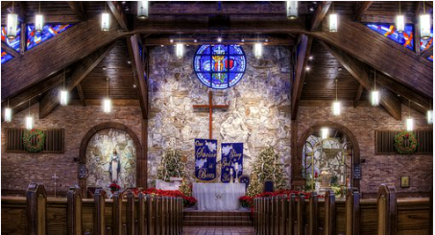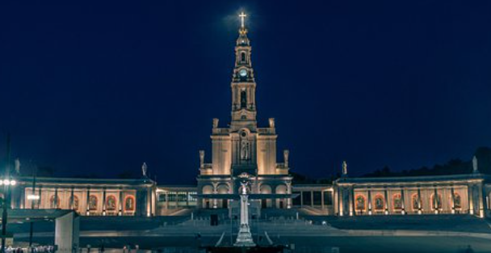
² Praise Him for His mighty deeds;
Praise Him according to His excellent greatness.
³ Praise Him with trumpet sound;
Praise Him with harp and lyre.
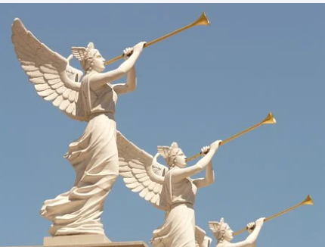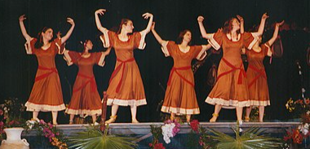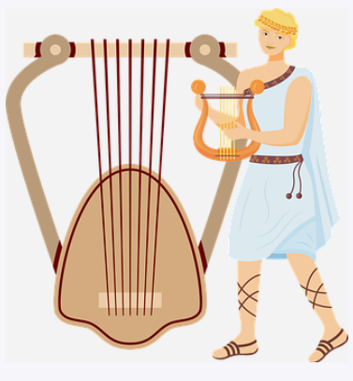
⁴ Praise Him with tambourine and dancing;
Praise Him with stringed instruments and flute.
⁵ Praise Him with loud cymbals;
Praise Him with resounding cymbals.
⁶ Everything that has breath shall praise the Lord.
Praise the Lord!

Time to release your creativity. Think of His many blessings, the wonders of the expanses of heaven, the beauty of a sunset, rose, a newborn, a bird in flight. Now put a melody to it and Sing a New Song of Praises to the Lord.

Father, indeed you are forever worthy of our Praise. Let us be joyful. Great is our God and greatly to be praised. May our hearts be full and our lips release a sacrifice of praise.
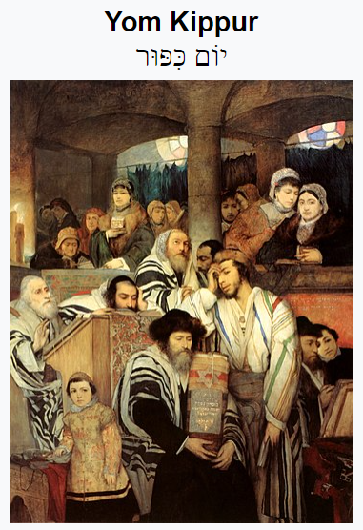
Wednesday, Oct 5 Yom Kippur suggested reading – Hebrews 9
Yom Kippur is a day of fasting, confessions, and receiving and then celebrating God’s forgiveness.
Much of this devotional series has included opportunity to reflect on our need for cleaning our hearts before the Lord. Today in the Jewish calendar is the day to come to the confessional and bring these reflections along with our petitions for forgiveness to the Lord. For the Jews it is a full day in the temple of contemplation and beautiful music lifting hearts to the Lord. After sundown it is followed by a refreshing feast and clean hearts.
This may be an ideal day to bring forth your lists and seek God’s forgiveness on any issues you need to address and then burn your lists as an act of first step of setting yourself free of these burdens. Then put on some of your favorite worship music and let your heart lift Him praise and receive from Him the blessed assurance of new life and freedoms.
Father, on this the day that your people have traditionally entered your presence seeking atonement for sin, we thank you for Jesus. Once and for all time the temple curtain was torn from top to bottom as Jesus ushered in a new way for people to enter the Holy of Holies and freely access your forgiveness whenever it is needed simply by turning to Jesus our faithful redeemer.
Let us pray for the eyes of the Jews to be opened and see that the Messiah, the Lord Jesus has come. Let us appreciate them as fellow seekers of your ways. Like them you still call us to seek purity as we walk humbly, faithfully and full of your loving grace and kindness to all. Let us embed days of remembrance of your greatness, our unworthiness and need for atonement that Jesus provided into our traditions.
Let us not think of ourselves as haughty, prideful achievers, but as servants of loving kindness and encouraging each other to be the best that we can be. Let our hearts be open to be led into the destiny you have set within our hearts from when we were knit together in our mother’s womb. Great is our God and greatly to be praised. Send us out refreshed and renewed to serve.

