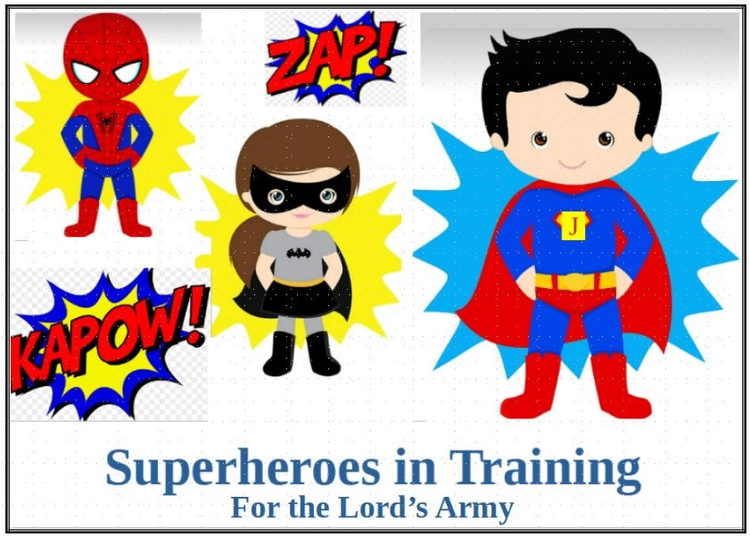
SUPERHEROES IN TRAINING – FOR THE LORD’s ARMY

DAY 1 MUSIC Dem Bones Gonna Rise Again, Standing in the Need of Prayer, Lord’s Army, Only a Boy Named David
RECREATION Hard to Chews and Volley BeachBall
CRAFT Belt of Truth
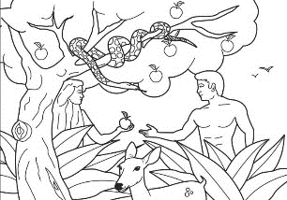
.
DAY 2 MUSIC The BIBLE Only a Boy Named David Jonah Song Such a Time Is This Jesus Loves Me Lord’s Army
RECREATION Bowling Down Enemies in His Strength
CRAFT Helmet of Salvation

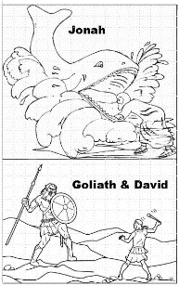
DAY 3 MUSIC Mary Had a Baby Jesus wants me for a Sunbeam
Zaccheus– I Wanna Walk on Water Jesus Loves Me
Silver and Gold Have I None
RECREATION Bible Freeze Tag and Peter Walks on Water
CRAFT Shield of Faith

Day 4. MUSIC Mary Had a Baby Jesus Loves Me
Silver and Gold Have I None Lord’s Army Armor of God
RECREATION Bible Story Freeze Tag/ Volley Beach Ball
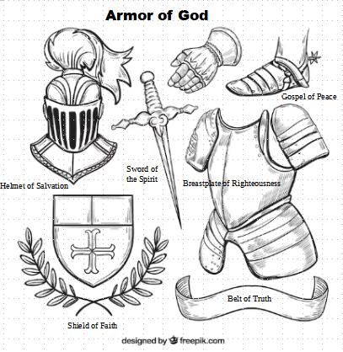
CRAFT Sandals of the Gospel of Peace

DAY 5 MUSIC Dem Bones Gonna Rise Again Only a Boy Named David Jonah Song For Such a Time Is This Jesus Loves Me
Lord’s Army Standing in the Need of Prayer Armor of God
RECREATION Choice Day: Volley Beach Ball, Freeze Tag, Bowling
CRAFT Sword of the Spirit

