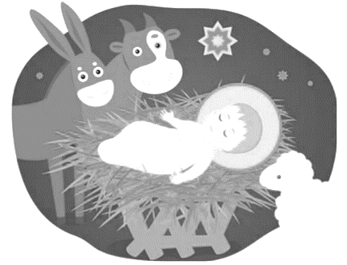
Away in a Manger no crib for a bed
The little Lord Jesus laid down his sweet head
The stars in the sky looked down where he lay
The little Lord Jesus asleep on the hay.
The cattle are lowing the baby awakes
The little Lord Jesus no crying he makes.
I love you Lord Jesus; look down from the sky
And stay by my side until morning is nigh.
Be near me Lord Jesus I ask you to stay
Close by me forever, and love me, I pray.
Bless all the dear children in your tender care,
And fit us for heaven, to live with you there.

Angels We Have Heard on High
Sweetly singing o'er the plains
And the mountains in reply
Echoing their joyous strains
Chorus Gloria, Gloria, Gloria
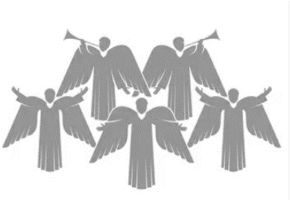
In excelsis Deo
Shepherds, why this jubilee?
Why your joyous strains prolong?
Say what may the tidings be
Which inspire your heavenly song
Come to Bethlehem and see
Him Whose birth the angels sing
Come, adore on bended knee
Christ the Lord, the newborn King

See within in a manger laid
Jesus Lord of Heav'n and Earth
Mary, Joseph, lend your aid
With us sing our Savior's birth

Hark! the Herald Angels Sing
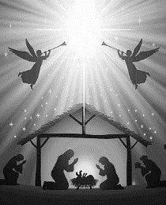
"Glory to the newborn King!
Peace on earth and mercy mild
God and sinners reconciled"
Joyful, all ye nations rise
Join the triumph of the skies
With angelic hosts proclaim:
"Christ is born in Bethlehem"
Hark! the herald angels sing:
"Glory to the newborn King!"
Christ by highest Heav'n adored
Christ the everlasting Lord!
Late in time behold Him come
Offspring of a Virgin's womb
Veiled in flesh the Godhead see;
Hail the incarnate Deity
Pleased as man with man to dwell
Jesus, our Emmanuel
Hark! the herald angels sing:
"Glory to the newborn King!"
Hail the Heav'n-born Prince of Peace!
Hail the Son of Righteousness!
Light and life to all He brings
Ris'n with healing in His wings
Mild He lays His glory by
Born that man no more may die
Born to raise the sons of earth
Born to give them second birth
Hark! the herald angels sing:
"Glory to the newborn King!"
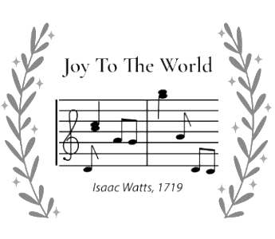

Joy to the World the Lord has come
Let earth receive her King
Let every heart prepare Him room
And heaven and nature sing 3x
Joy to the earth, the Savior reigns
Let men their songs employ
While fields and floods, rocks, hills, and plains
Repeat the sounding joy 3x
No more let sins and sorrows grow
Nor thorns infest the ground
He comes to make His blessings flow
Far as the curse is found 3x
He rules the world with truth and grace
And makes the nations prove
The glories of His righteousness
And wonders of His love 3x

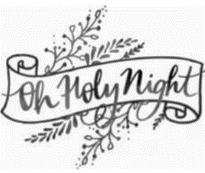

O Holy night! The stars are brightly shining
It is the night of our dear Savior's birth
Long lay the world in sin and error pining
'Til He appears and the soul felt its worth
A thrill of hope the weary world rejoices
For yonder breaks a new and glorious morn
Fall on your knees; O hear the Angel voices!
O night divine, O night when Christ was born
O night, O Holy night, O night divine!
Led by the light of Faith serenely beaming
With glowing hearts by His cradle we stand
So led by light of a star sweetly gleaming
Here come the Wise Men from Orient land
The King of kings lay thus in lowly manger
In all our trials born to be our friend
He knows our need, to our weakness is no stranger
Behold your King; before Him lowly bend
Behold your King; before Him lowly bend
Truly He taught us to love one another;
His law is love and His Gospel is Peace
Chains shall He break, for the slave is our brother
And in His name, all oppression shall cease
Sweet hymns of joy in grateful chorus raise we
Let all within us Praise His Holy name
Christ is the Lord; O praise His name forever!
His power and glory evermore proclaim
His power and glory evermore proclaim

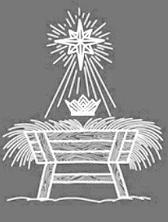
O Come, O Come, Emmanuel
And ransom captive Israel
That mourns in lonely exile here
Until the Son of God appear

Refrain: Rejoice! Rejoice! Emmanuel
Shall come to thee, O Israel

O come, O come, Thou Lord of might
Who to Thy tribes, on Sinai's height
In ancient times didst give the law
In cloud, and majesty and awe

O come, Thou Rod of Jesse, free
Thine own from Satan's tyranny
From depths of hell Thy people save
And give them victory o'er the grave

O come, Thou Dayspring, come and cheer
Our spirits by Thine advent here
Disperse the gloomy clouds of night
And death's dark shadows put to flight

O come, Thou Key of David, come
And open wide our heavenly home
Make safe the way that leads on high
And close the path to misery

O come, Thou Wisdom from on high
And order all things, far and nigh
To us the path of knowledge show
And cause us in her ways to go

O come, desire of nations, bind
In one the hearts of all mankind
Bid Thou our sad divisions cease
And be Thyself our King of peace

O come, all ye faithful,
Joyful and triumphant!
O come ye, O come ye to Bethlehem;
Come and behold him
Born the King of Angels:
O come, let us adore Him,
O come, let us adore Him,
O come, let us adore Him,
Christ the Lord.
God of God,
Light of Light,
Lo, he abhors not the Virgin’s womb;
Very God,
Begotten, not created:
Sing, choirs of angels,
Sing in exultation,
Sing, all ye citizens of Heaven above!
Glory to God
In the highest:
Yea, Lord, we greet thee,
Born this happy morning;
Jesus, to thee be glory given!
Word of the Father,
Now in flesh appearing!

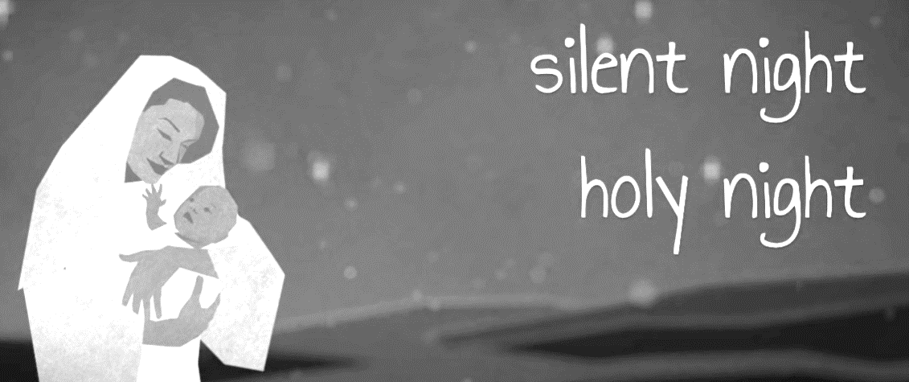
Silent Night, holy night
All is calm, all is bright
Round yon Virgin, Mother and Child
Holy Infant so tender and mild
Sleep in heavenly peace
Sleep in heavenly peace
Silent night, holy night
Shepherds quake at the sight
Glories stream from heaven afar
Heavenly hosts sing Alleluia
Christ the Savior is born
Christ the Savior is born
Silent night, holy night
Son of God, love's pure light
Radiant beams from Thy holy face
With the dawn of redeeming grace
Jesus Lord, at Thy birth
Jesus Lord, at Thy birth

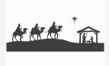
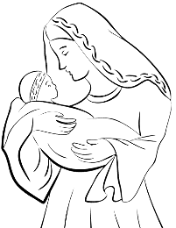
We Three Kings of Orient Are
Bearing gifts we traverse afar
Field and fountain
Moor and mountain
Following yonder star
Chorus:
O star of wonder, star of night
Star with royal beauty bright
Westward leading, still proceeding
Guide us to thy perfect light
Born a King on Bethlehem's plain
Gold I bring to crown Him again
King forever, ceasing never
Over us all to reign
Frankincense to offer have I
Incense owns a Deity nigh
Prayer and praising, all men raising
Worship Him, God most high
What Child is This, who, laid to rest,
On Mary’s lap is sleeping,
Whom angels greet with anthems sweet
While shepherds watch are keeping?
This, this is Christ the King,
Whom shepherds guard and angels sing;
Haste, haste to bring Him laud,
The babe, the son of Mary!
Why lies He in such mean estate
Where ox and ass are feeding?
Good Christian, fear: for sinners here
The silent Word is pleading.
Nails, spear shall pierce him through,
The Cross be borne for me, for you;
Hail, hail the Word Made Flesh,
The babe, the son of Mary!
So bring Him incense, gold, and myrrh;
Come, peasant, king, to own Him!
The King of Kings salvation brings;
Let loving hearts enthrone Him!
Raise, raise the song on high!
The virgin sings her lullaby.
Joy! joy! for Christ is born,
The babe, the son of Mary!
God Rest Ye Merry, Gentlemen
Let nothing you dismay
Remember, Christ, our Savior
Was born on Christmas day
To save us all from Satan's power
When we were gone astray
O tidings of comfort and joy
Comfort and joy
O tidings of comfort and joy
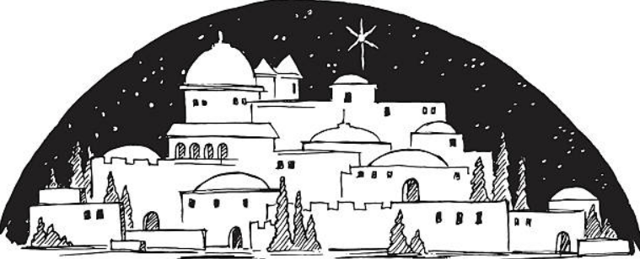In Bethlehem, in Israel
This blessed Babe was born
And laid within a manger
Upon this blessed morn
The which His Mother Mary
Did nothing take in scorn
O tidings of comfort and joy
Comfort and joy
O tidings of comfort and joy
From God our Heavenly Father
A blessed Angel came
And unto certain Shepherds
Brought tidings of the same
How that in Bethlehem was born
The Son of God by Name
O tidings of comfort and joy
Comfort and joy
O tidings of comfort and joy

It came upon the midnight clear,
That glorious song of old,
From angels bending near the earth,
To touch their harps of gold;
“Peace on the earth, good will to men,
From Heav’n’s all-gracious King.”
The world in solemn stillness lay,
To hear the angels sing.
Still through the cloven skies they come
With peaceful wings unfurled,
And still their heav’nly music floats
O’er all the weary world;
Above its sad and lowly plains,
They bend on hov’ring wing,
And ever o’er its Babel sounds
The blessed angels sing.
Yet with the woes of sin and strife
The world has suffered long;
Beneath the angel strain have rolled
Two thousand years of wrong;
And man, at war with man, hears not
The love-song which they bring;
Oh, hush the noise, ye men of strife
And hear the angels sing.
And ye, beneath life’s crushing load,
Whose forms are bending low,
Who toil along the climbing way
With painful steps and slow,
Look now! for glad and golden hours
Come swiftly on the wing.
Oh, rest beside the weary road,
And hear the angels sing!
For lo! the days are hast’ning on,
By prophet seen of old,
When with the ever-circling years
Shall come the time foretold
When Christ shall come and all shall own
The Prince of Peace, their King,
And saints shall meet Him in the air,
And with the angels sing.

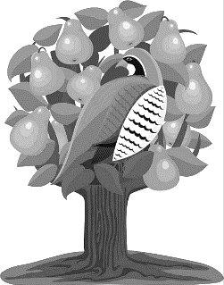
On the First Day of Christmas
On the first day of Christmas my true love gave to me
A partridge in a pear tree
Two turtle doves
Three French hens
Four calling birds
Five golden rings
Six geese a-laying
Seven swans a-swimming
Eight maids a-milking
Nine ladies dancing
Ten lords a-leaping
Eleven pipers piping
Twelve drummers drumming

