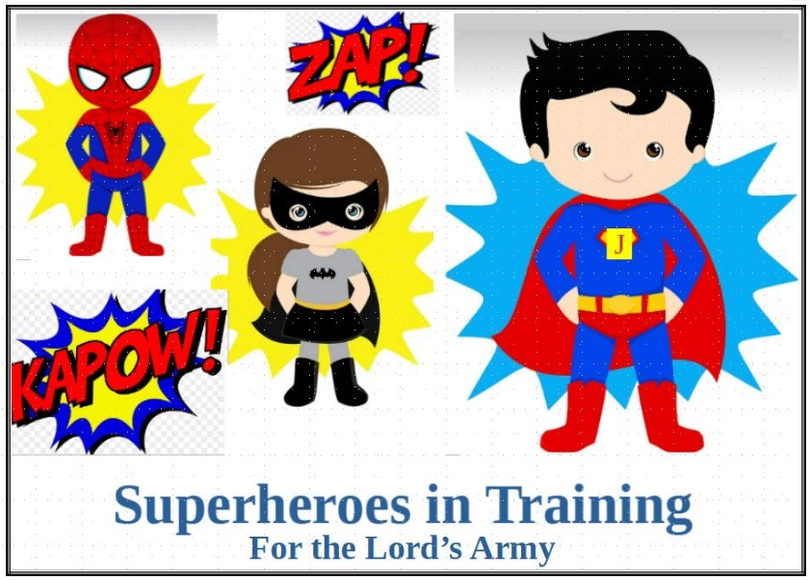
SUPERHEROES IN TRAINING – FOR THE LORD’s ARMY

DAY 1 Theme – I’m a superhero in training & Sin needs a Savior
Bible Memory Verse - Romans 6:23 For the wages of sin is death, but the free gift of God is eternal life in Christ Jesus our Lord.
Adam and Eve ate of the tree of knowledge of good and evil. Sin took root in mankind.

DAY 2 Theme – God seeks people (young/old) to walk close with Him to be His superheroes.
Bible Verse: You were born for such a time as this - Esther 4:14
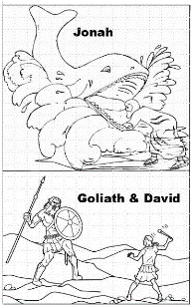
David, Jonah, and Esther are examples of God’s superheroes.

DAY 3 Theme – Jesus is God’s son and came be our Savior.
Bible Verse: John 3:16 For God so loved the world that whosoever believes on Him should not perish, but have everlasting life.
Jesus was sinless, taught and shared God’s loving healing, and died so we could know God intimately as our Father.

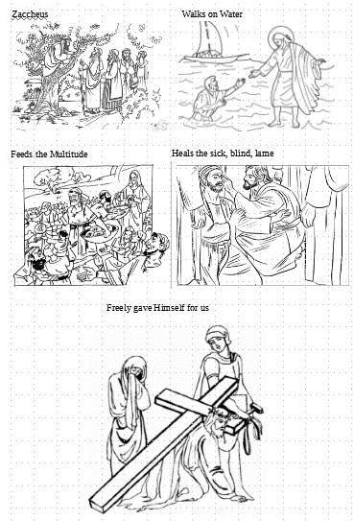
Day 4 Theme – You can become God’s superhero – Put on the full armor of God.
Bible Verses: Middle age group Ephesians 6:14 Stand firm then, with the belt of truth buckled around your waist, with the breastplate of righteousness in place, 15 and with your feet fitted with the readiness that comes from the gospel of peace.
Oldest Group16 In addition to all this, take up the shield of faith, with which you can extinguish all the flaming arrows of the evil one. 17 Take the helmet of salvation and the sword of the Spirit, which is the word of God.
Youngest group - 18 And pray in the Spirit on all occasions with all kinds of prayers and requests.
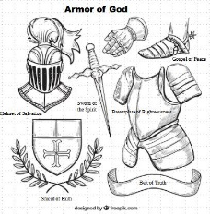
Learn how the armor of God protects us.

DAY 5 Theme – Prayer changes things – Pray at all times.
Bible Verse: Matthew 6: 9 “This, then, is how you should pray:“‘Our Father in heaven, hallowed be your name,10 your kingdom come, your will be done, on earth as it is in heaven.11 Give us today our daily bread. 12 And forgive us our debts, as we also have forgiven our debtors.13 And lead us not into temptation, but deliver us from the evil one.’
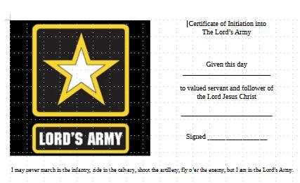
Pray at all times – Praising God for his holiness, Asking for daily needs, Forgiving us as needed, and Give us guidance to avoid temptation. God answers prayer. Graduate with a certificate of Membership in the Lord’s Army. Now continue to learn more and apply your training – daily wear the Lord’s armor and pray– obey God, and love others.

